Preliminary Results of the Anti-Symmetric Reconstruction Algorithm
De novo peptide sequencing can be formulated as a graph-theoretic problem of finding a longest path through the spectrum graph of a mass spectrum (Dancik et al. J. Comp. Biol. 1999). In the case of well-fragmented spectra, this path often traverses the peaks representing b-ions (b-ladder) and spells out the amino acid of the unknown peptide. However, the reconstructed sequence is often incorrect in the case of poorly fragmented and noisy spectra. Moreover, the presence of anti-symmetric relationships between fragment ions—such as complementary b and y ions—introduces ambiguity, as the reconstructed path has a tendency to switch between peaks encoding b- and y-ion (rather than follow the b-ladder) and thus result in an incorrect reconstruction. To address this complication, Dancik et al., 1999 introduced the Anti-Symmetric Path (ASP) Problem and even announced its solution as “to be described elsewhere”. However, their manuscript has never been published—the first published solution has been given by Chen et al., J. Comp. Biol. 1999).
Two-dimensional partial covariance mass spectrometry (2D-PC-MS) has significantly alleviated suppressed the noise in spectra and thus provided a hope for more accurate peptide reconstruction using the spectrum graph approach. However, application of the spectrum graph approach to 2D-PC-MS spectra is still problematic as this approach does not address the anti-symmetric path problem.
We developed a new version of the ASP algorithm specifically designed to operate on 2D-PC-MS data. Given masses at the parental conservation line, our algorithm constructs the 2D ASP graph (rather than 1D spectrum graph) and finds the longest path in this graph that is guaranteed to satisfy the anti-symmetric property, i.e., it does not mix the b- and y-ladders. By explicitly leveraging anti-symmetric constraints inherent in peptide fragmentation, this approach dramatically reduces the solution space as compared to the spectrum graph approach. In most cases, the peptide dictionary is reduced to fewer than five possible reconstructions with the appearance of spurious points, and often to a single, correct peptide sequence. Together, these advances provide a robust framework for accurate de novo peptide sequencing.
We have evaluated the algorithm on the available datasets, and the results demonstrate strong performance. To clearly illustrate the outcomes of the algorithm, we constructed a series of visualizations of the reconstruction results for each dataset. In the current analysis, only data pairs located on the parental conservation lines among the top 50 ranked pairs were used for peptide reconstruction.
An example of this complete representation is shown below.

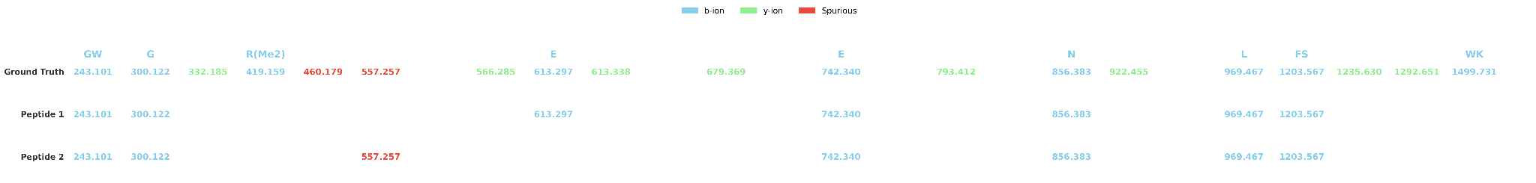

For this panel, we use the known peptide sequence and the points on the parental conservation line to annotate each mass as a b ion (blue), y ion (green), or spurious (red). This representation is shown in the top row.
The two rows below (“Peptide 1” and “Peptide 2”) correspond to the two longest paths in the 2D ASP graph. Each number in a row indicates a mass that the algorithm assigned as a b ion for that path: blue denotes a correct identification (true b ion), whereas any non-blue label indicates an incorrect assignment. In this example, Peptide 1 is the correct reconstruction because all annotated masses in the row are blue. Peptide 2 is incorrect because it incorrectly includes 557, which is a spurious mass.
This panel below shows the visualization of the two most prominent (longest) paths identified by the ASP algorithm. The green path corresponds to the correct reconstruction, while the purple path represents the equally-scoring but incorrect solution. The incorrect path includes the mass 557, which—consistent with previous observations—is marked as a spurious point (red) on both the x- and y-axes.

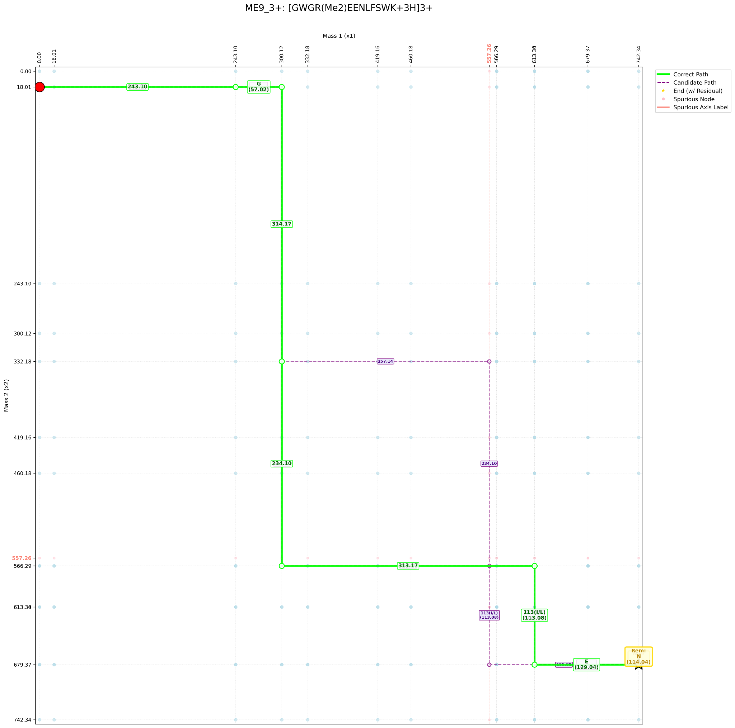

To interpret this visualization, one reads the horizontal edges from left to right until reaching the endpoint (referred to as the midpoint of the peptide)—these edges spell out the amino acid sequence up to the midpoint that corresponds to the half of the parent mass. The vertical edges spell out the second half of the peptide in the reverse order. Finally, the middle amino acid (that spans the midpoint) is reconstructed based on the special rule that we will describe later.
For the correct (green) path, the reconstructed sequence of masses is:

243 (G + W) → 57 (G) → 313 (R(ME2) + E) → 129 (E) → 114 (N, midpoint) → 113 (I/L) → 234 (F + S) → 314 (K + W)

This reconstruction perfectly matches the known peptide sequence.

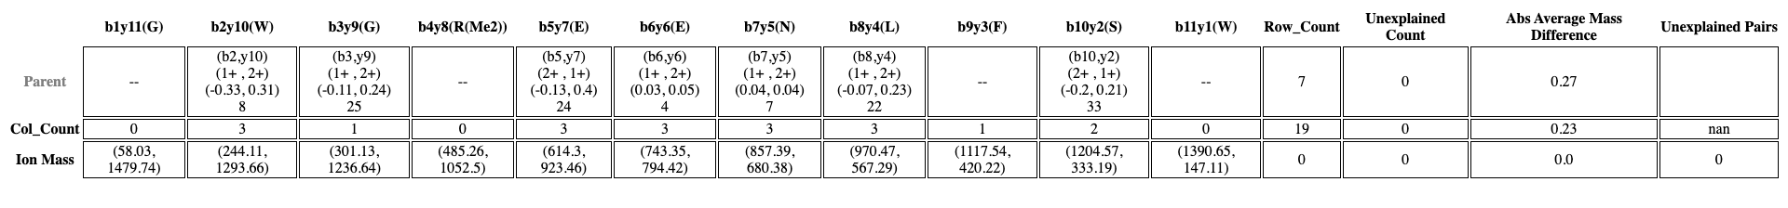
This table summarizes all masses located on the parental conservation lines that were used for reconstruction. A dash (“–”) indicates that no corresponding mass pair was found among the top 50 data pairs. In general, the more entries populated in a parental row, the more informative the data are, leading to a more detailed reconstruction.

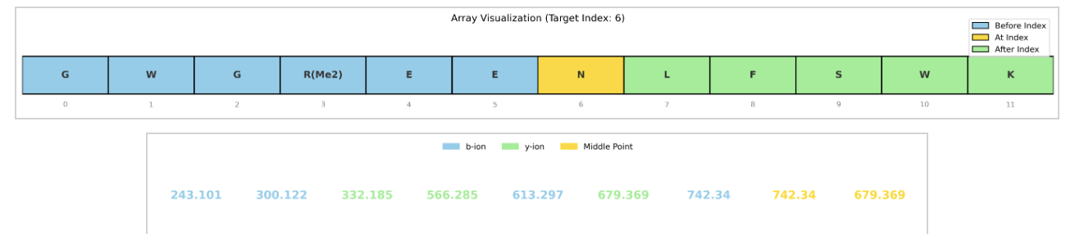
These plots do not introduce additional quantitative information; they serve as an intuitive visualization of the reconstruction process and may be helpful for illustrating the algorithm’s behavior during explanation and discussion. These two graphs provide a schematic visualization of how the peptide is reconstructed. Green segments indicate regions identified as y ions, while blue segments represent regions identified as b ions, and the yellow part means it was inferred by the midpoint. The numbers along the bottom correspond to masses from the first half of the spectrum, with color coding indicating whether each mass has been assigned as a b ion, a y ion, or used as the midpoint.
Here we present the results for all evaluated datasets. For many cases, a single, correct longest path is identified (Marked as *). In the remaining cases, the presence of spurious data points leads to multiple longest paths; however, the number of the highest-scoring candidates is always fewer than five, and the correct reconstruction is consistently included among them. This represents a substantial improvement over traditional longest-path approaches on directed acyclic graphs, which often generate thousands and even millions of candidate solutions. (Each clickable link leads to the PDF file for the corresponding visualization.)
ME4_2+*
Peptide Length: 13
Total Number of Pairs: 9
Number of Interpretable Pairs: 8
Number of Reconstructed Masses: 9 (There is one data pair in which only one value is interpretable in terms of the terminal ion; normally, this number should not exceed the total number of interpretable pairs.)
Does the Correct Peptide Achieve the Highest Score? Yes
Number of Highest-Scoring Reconstructions; 1
Number of Highest-Scoring Reconstructions Containing Incorrect (Red) Peak–Peak Pairs: 0

ME4_3+
Peptide Length: 13
Total Number of Pairs: 6
Number of Interpretable Pairs: 6
Number of Reconstructed Masses: 6
Does the Correct Peptide Achieve the Highest Score? Yes
Number of Highest-Scoring Reconstructions: 2
Number of Highest-Scoring Reconstructions Containing Incorrect (Red) Peak–Peak Pairs: 1

ME8_3+*
Peptide Length: 14
Total Number of Pairs: 9
Number of Interpretable Pairs: 7
Number of Reconstructed Masses: 7
Does the Correct Peptide Achieve the Highest Score? Yes
Number of Highest-Scoring Reconstructions: 1
Number of Highest-Scoring Reconstructions Containing Incorrect (Red) Peak–Peak Pairs: 0

ME9_2+
Peptide Length: 12
Total Number of Pairs: 8
Number of Interpretable Pairs: 7
Number of Reconstructed Masses: 7
Does the Correct Peptide Achieve the Highest Score? Yes
Number of Highest-Scoring Reconstructions: 2
Number of Highest-Scoring Reconstructions Containing Incorrect (Red) Peak–Peak Pairs: 0

ME9_3+
Peptide Length: 12
Total Number of Pairs: 8
Number of Interpretable Pairs: 7
Number of Reconstructed Masses: 7
Does the Correct Peptide Achieve the Highest Score? Yes
Number of Highest-Scoring Reconstructions: 2
Number of Highest-Scoring Reconstructions Containing Incorrect (Red) Peak–Peak Pairs: 0

ME14_2+*
Peptide Length:12
Total Number of Pairs: 6
Number of Interpretable Pairs: 6
Number of Reconstructed Masses: 6
Does the Correct Peptide Achieve the Highest Score? Yes
Number of Highest-Scoring Reconstructions: 1
Number of Highest-Scoring Reconstructions Containing Incorrect (Red) Peak–Peak Pairs: 0

ME14_3+*
Peptide Length
Total Number of Pairs: 12
Number of Interpretable Pairs: 9
Number of Reconstructed Masses: 9
Does the Correct Peptide Achieve the Highest Score? Yes
Number of Highest-Scoring Reconstructions: 1
Number of Highest-Scoring Reconstructions Containing Incorrect (Red) Peak–Peak Pairs: 0

ME16_3+*
Peptide Length: 12
Total Number of Pairs: 8
Number of Interpretable Pairs: 7
Number of Reconstructed Masses: 7
Does the Correct Peptide Achieve the Highest Score? Yes
Number of Highest-Scoring Reconstructions: 1
Number of Highest-Scoring Reconstructions Containing Incorrect (Red) Peak–Peak Pairs: 0

ME17_2+*
Peptide Length: 8
Total Number of Pairs: 5
Number of Interpretable Pairs: 5
Number of Reconstructed Masses: 5
Does the Correct Peptide Achieve the Highest Score? Yes
Number of Highest-Scoring Reconstructions: 1
Number of Highest-Scoring Reconstructions Containing Incorrect (Red) Peak–Peak Pairs: 0

ME17_3+
Peptide Length: 8
Total Number of Pairs: 8
Number of Interpretable Pairs: 5
Number of Reconstructed Masses: 5
Does the Correct Peptide Achieve the Highest Score? Yes
Number of Highest-Scoring Reconstructions: 5
Number of Highest-Scoring Reconstructions Containing Incorrect (Red) Peak–Peak Pairs: 4

PH15_2+*
Peptide Length: 11
Total Number of Pairs: 7
Number of Interpretable Pairs: 7
Number of Reconstructed Masses: 7
Does the Correct Peptide Achieve the Highest Score? Yes
Number of Highest-Scoring Reconstructions: 1
Number of Highest-Scoring Reconstructions Containing Incorrect (Red) Peak–Peak Pairs: 0

UN14_2+
Peptide Length: 11
Total Number of Pairs: 6
Number of Interpretable Pairs: 6
Number of Reconstructed Masses: 6
Does the Correct Peptide Achieve the Highest Score? Yes
Number of Highest-Scoring Reconstructions: 2
Number of Highest-Scoring Reconstructions Containing Incorrect (Red) Peak–Peak Pairs: 0

UN15_2+*
Peptide Length: 11
Total Number of Pairs: 7
Number of Interpretable Pairs: 7
Number of Reconstructed Masses: 7
Does the Correct Peptide Achieve the Highest Score? Yes
Number of Highest-Scoring Reconstructions: 1
Number of Highest-Scoring Reconstructions Containing Incorrect (Red) Peak–Peak Pairs: 0

